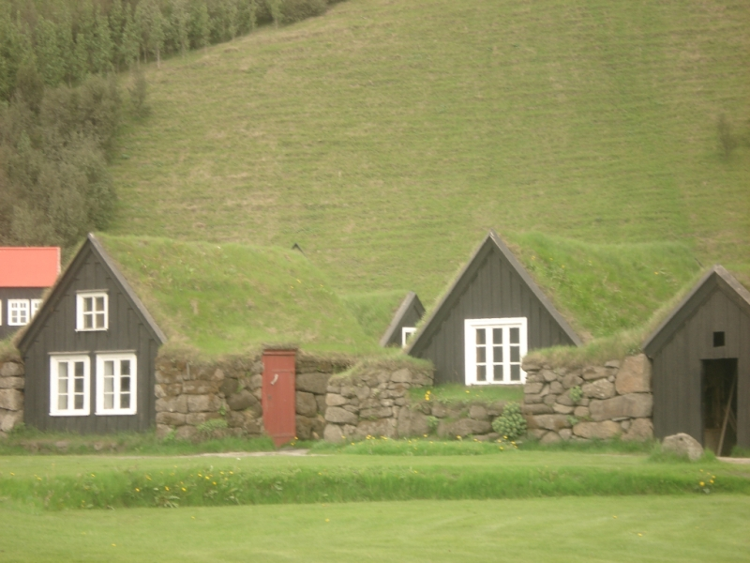

**THE INTERNATIONAL ASSOCIATION**

**FOR THE STUDY OF DREAMS**

**TORONTO REGIONAL**

**ORGANIZATIONAL MEETING**

**ANNUAL CONFERENCE**

**PRESENTATION VETTING**

**FACILITATED DREAM**

**SHARING**

**~**

**2014/2015 EVENTS**

**DREAMS & THEMES**

**PLANNING SESSION**

**~**

**Registration required by May 6, 2014** [**mara@healgently.ca**](mailto:mara@healgently.ca)

**Event Location**

**7 Beaver Valley Road, Toronto. ON M3H 4R8**

**(Allen Road/Sheppard Avenue)**

**SATURDAY, MAY 10, 2014**

**10AM TO 4PM**

**POTLUCK LUNCH**

**$10 for the ‘kitty’**

Copyright Mara Zadnoff 2010